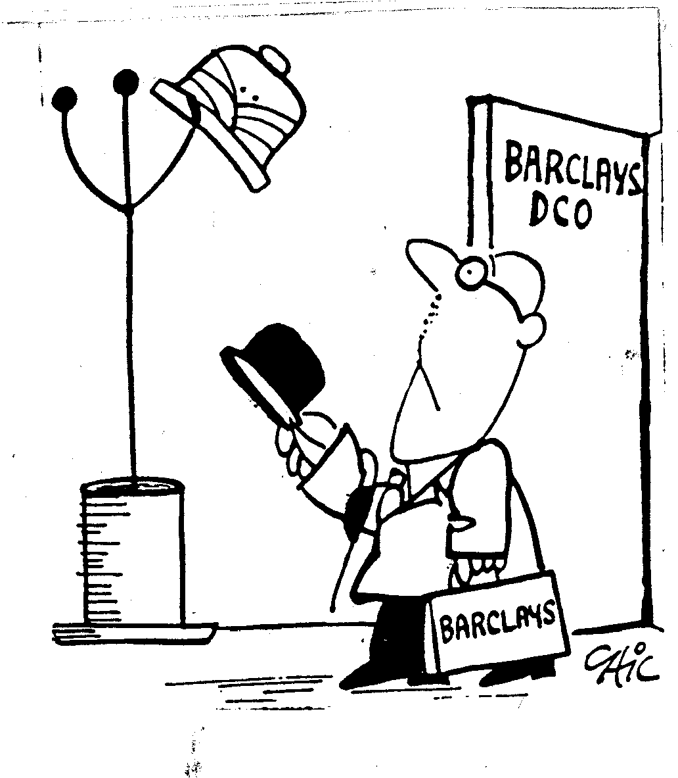

BIPC Newsletter
Number 72

May 2015
MEMBER NEWS
Our oldest member, DOROTHY BATEMAN, was born on Guy Fawkes Day 1908. After completing a Pitman’s course she joined the Barclays Gracechurch Street Branch from where she retains memories of the flamboyant DENNIS LOVELL lighting up the office. In 1934 she married CLIFF, who at that time worked for the Bank of England, and she became a housewife, giving birth to two sons HOWARD in 1938 and Paul in 1944. For many years Howard was a member of the BIPC Committee and he is also a Past Captain of the Barclays International Golfing Society. Cliff moved from the Bank of England to DC&O, working at Circus Place and Goodenough House. Dorothy has been drawing her widows’ pension since 1988 and remained self sufficient until she was one hundred, when for health reasons she had to move to a residential care home. This spring she is due to star in a film to be shot for the Walton Trust which runs the care home where she lives.
DES LANE recently recalled that whilst working at 29 Gracechurch Street he once heard the building had previously housed a gunsmith and decided to discover whether or not this was in fact the case. His research disclosed that for 89 years 29 Gracechurch Street had been the home of John Blanch and Son, Gun and Rifle Makers and when they moved to 20 Cullum Street, London, EC3 in 1916 the premises were subsequently acquired by the Colonial Bank, who at that time had decided to open branches in West Africa to supplement their long standing representation in the West Indies and as a result needed a larger London office. An interesting piece of both City of London and Barclays International history.
In Newsletter No. 71 we asked for memories of interesting people members had come across during their Barclays’ careers. So far we have received just two responses, but further contributions will be most welcome.
In 1984 BILL PRICE took over from NICK BRENTNALL as Seychelles Country Manager. During the handover Nick asked him to look under one of the visitor’s chairs where he found a note reading “Bo Derek sat here”. A few months later a devotion of Nuns from the Missionary of Charity came to see Bill and introduce an important visitor who turned out to be Mother Theresa and yes, she sat in that same chair. But no, Bill was not tempted to add to Nick’s message!
In the early 1950’s JULIAN WATHEN was in charge of statements, all of which were written up by hand, at Government Road Branch, Nairobi. He was supported by BALWANT SINGH and PETER NYAKIAMO, the three of them sharing one desk and two chairs. The furniture situation was not a problem as one of the three had always to be at the counter dealing with customers. One of these customers, before the days of Mau Mau, was Jomo Kenyatta who few of the other European members of staff were willing to talk to !
After retiring from Zambia in 2000 IAIN and TRUDI KNAPMAN moved to Uganda, building a house near Gaba outside Kampala. Iain joined the Board of BBU as a non-executive director until 2007. During their time in Uganda Iain also chaired the local arm of an NGO promoting improved livelihoods through sustainable agricultural practices and served on the board of the African Medical Research Foundation in Nairobi. On returning to the UK, once grandchildren appeared, amongst other voluntary roles Iain became Chairman of the Trust for African Orphans. Iain and Trudi aim to visit Uganda every two years and spend Spring and Autumn on the Isle of Tiree.
Having lived in Woburn, Bedfordshire for 20 years, ROY and DILYS MAGGS moved house to near Ringwood, Hampshire. Although age has called a halt to playing cricket, in the summer Roy can be found at the Oval watching Surrey, whilst golf and walking dogs take up a great deal of time. Roy is in contact with friends from his Export Finance days, but would love to hear from anyone who remembers him from his time in Poole during the 80’s.
Following a career that took in Nigeria, Libya, Zambia and finally BZW, PETER MACKENZIE and his wife GILLIAN retired to Torbay, but for the past 12 years have lived just outside Salisbury. His interests involve various voluntary committees, particularly as treasurer or secretary, and holidays include a number of cruises, one to Sydney to celebrate their golden wedding. Peter and Gillian particularly enjoy meeting up with friends for pub lunches.
For over twenty years DON LONSDALE’S mother lived in a Careways home in Worthing where she received wonderful care and affection. Towards the end of his mother’s life Don rashly told the incumbent Chairman of the group that if there was anything he could do to help he would be happy to oblige. He subsequently spent the next 15 years running the finances and later Chairing the Charity, being exposed to the very real issues posed by dementia in old age along with the problems of staffing care homes with committed carers and the desperately tough financial challenges, where budgets in local authorities are being pared to the bone. However, he was privileged to work with some wonderful people, one particular carer coming to mind who brought her sleeping bag to work so she could sleep on the floor at the Home and would not be kept away by the winter snow.
RAY ARCHER believes that if they had experienced the medical services in Nigeria, people would not be so critical of the NHS in this country. During a transfer drive from Lagos to Jos Ray found himself in serious pain. On reaching Minna, where he had planned to stay overnight with GRAHAM ALABASTER, the doctor diagnosed a fistula and Ray was put on the next train to Kaduna. Taken to a hotel and then to the General Hospital, he was asked to climb fully dressed onto the operating table and went under with the anaesthetic just as they pulled off his trousers. Ray came back to consciousness in the hotel and after a couple of days continued his journey to Jos, where six weeks later his operation was completed/corrected at the Vom Christian Hospital. One year later his daughter Helen was born in the same hospital.
After leaving Barclays BRIAN LAWRENCE looked to educate himself in hand skills such as furniture making and glass crafts. Initially self taught, and later suffering from MS with the loss of the optic nerve of the right eye, Brian enrolled for various courses including the City and Guilds were he achieved a distinction and was put forward for a medal of excellence, coming second in the whole Country. Being a child of the 60’s Brian was, and still is, a lover of the more adventurous bands of that period so as his major project he chose “A Homage to Pink Floyd”, which included items such as Money, Time Leaving the Dark Side, Another Brick Wall and Shine on You Crazy Diamonds. A photograph of Brian’s design presentation can be found on the Club website.
With all their children and grandchildren living in North America ROY and SUSAN MASTERS spend four or five months of the year travelling and now keep a mobile home on that side of the Atlantic. However last year they also had a very pleasant vacation in southern Africa where they met up with, amongst others, VIV BARTLETT, DOC PASCOE and JOHN COLLET; all old friends from New York days.
In his book “Imperial Atrocities” Michael Arnold describes some of the colonial rituals that once surrounded cricket in West Africa. In particular he recalls the tale of cricket at the Enugu Club in Eastern Nigeria where up until 1959 the Captain always came from the Colonial Administration. Considerable social rumpus arose when the man elected as captain in 1959 was Geoff Jones, the manager of the local Ford dealers, a very competent cricketer but from “trade”. Nigerian independence followed soon after! Were any of our members playing cricket in Enugu at this time?
Writing from his home in Guernsey, MALCOLM MAUGER finds it difficult to believe he left the Bank 25 years ago. He has happy memories of his time in both Canada and Ghana, in particular the incident of “THE DROPPINGS” in Kumasi! Although Malcolm suffers from Peripheral Neuropathy, which affects his mobility and balance, he endeavours to keep active by exercising and swimming and “tries” to play nine holes of golf. He is involved in running a team of volunteers who deliver meals on wheels, is treasurer of a mens’ dining club, enjoys singing with a choir, plays euchre in a local league and still has connections with a captive insurance business. If any former colleagues are visiting Guernsey in the near future Malcolm would love to meet up with them.
After leaving Barclays, CLIFF KNOWLDEN spent eight years on the Board of Moscow Narodny Bank which meant he visited Russia on many occasions. From his personal experience, Cliff questions why the country always receives such a bad press in the UK. He specifically mentions the fact that the museums and churches are simply magnificent and coupling Moscow with a break in St. Petersburg produces a stunning cultural holiday. Cliff is an avid golfer and meets up with former Barclays’ colleagues at the Barclays International Golfing Society (BIGS) meetings. He is also a member of three other golf societies, which results in his playing numerous super, classic golf courses.
Having lived in Canada for 35 years, JOHN LIGHTBODY’s only real Barclays contact left in England is EDDIE CADE. However on a recent trip to the Caribbean to see his son, when sitting in a small cafe in Roadtown, British Virgin Islands looking out over the Caribbean Seas, a similar scene came to mind from 1966 in Orange Walk, British Honduras where he was about to undertake an inspection with the legendary CHARLES VASSALLO. Thoughts then turned to other colleagues from those inspection trips, JIMMY CRAIG in Nigeria, REG DINES in Malta and JOHN BUTCHER in Jamaica. John recalls that in those days bank management required wide experience, which helped to make it fun, you had to be a generalist to survive. So unlike today when generalist bankers seem to no longer exist.
JOLYON LARKMAN fondly remembers his time travelling to Thailand with TOM BALLANTYNE in the days of FIG and recalls PETER FORMHALS, the Bank’s then representative in Bangkok, saying he fancied retiring to run a noodle stall on Koh Samui ! Now JEAN and Jolyon often travel to Koh Samui, not to visit Peter’s noodle stall, but to see their son Giles, his wife Tai and their grandchildren. Giles is the Head of the Junior School at Panyadee School, the British school on Samui. Jolyon remains on the board of Suffolk Housing, where he has recently been involved in private placement fund raising to finance the construction of new homes.
CHRIS MARTIN was delighted to welcome BERNARD and BRENDA EASON to South Africa in February. The first week was spent exploring the Hermanus area, including visits to several wine estates and breweries. This was followed by a trip up the Garden Route, where in Knysna they enjoyed a pleasant evening with old friends from New York days, KEN and AVIS BOYD. Finally they spent a few days in Franschoek with JEFF and KAREN STOCKLEY.
DAVID LEUNG retired from Barclays in 2000, but was immediately recruited by WestLB AG Dusseldorf as Risk Director to set up their Liquidity Management Unit. He finally retired in 2006, but recently undertook an interesting treasury assignment in China sponsored by the International Finance Corporation. His task was to act as a freelance consultant to a Chinese Village and Township Bank to set up their Liquidity Risk Management unit and to re-organise their Asset Liability Risk Management function, both of which tasks have now been successfully completed. David and his wife CATHERINE enjoy travelling and seeking out some of the “Wonders of the World”. They recently returned from cruising off the Falkland Islands, around Cape Horn and through Drake’s Passage, the Beagle Channel and the Strait of Magellan.
Yera Hagopian, the daughter of the late HAGOP(JACOB) HAGOPIAN and ANAHID ( nee Sinanian the Cyprus Manager’s secretary to 1962) is now Managing Director of Cash Management in Barclays Corporate Banking.
EMMANUEL NORTEY has finally retired. After joining the Bank pensioners, Emmanuel became Chairman of the Enterprise Insurance Company for 15 years and the La Community Bank for 10 years. He was also Managing Director of the Consolidated Discount House Limited.
MANY THANKS TO ALL MEMBERS WHO HAVE SUBMITTED CONTRIBUTIONS TO THIS NEWSLETTER. NO CONTRIBUTIONS NO NEWSLETTER ! THE EDITOR IS ALWAYS DELIGHTED TO RECEIVE YOUR INPUT EITHER BY E-MAIL bennetttn6@btinternet.com (make sure though that you note the 3 ts in this address !) OR BY POST TO JOHN BENNETT GABLE VIEW, WELLESLEY CLOSE, CROWBOROUGH, EAST SUSSEX, TN6 1QP.

CLUB NEWS May 2015

IN MEMORIAM
Mr John ABPLANALP (1925/2015) Chatham
Mrs Jill BARNARD (1929/2014) Lytchett Matravers
Mr Leslie CASTILLO (1918/2015) Malta
Mrs P DAFFEY (1926/2015) Beckenham
Mr John DUNLEA (1937/2015) Bournemouth
Mrs Maria FORRESTER (1933/2015) Pimlico
Mrs Jane HARRISON (1927/2015) Sibsey
Mr Harry HOOKEY (1922/2015) Christchurch
Mrs Yolande LANE (1925/2015) Bclays House, Poole
Mr Patrick MAHER (1936/2015) Waltham Cross
Mr Brian MITCHELL (1935/2015) East Africa
Mr Brian NICHOLLS (1930/2015) Forest Hill
Mr Kesar PANESAR (1926/2015) Forest Gate
Mr Derk PELLY(1929/2015) Head Office
Mrs Audrey RITCHIE Widow of Mike
Mr Eric ROISER (1934/2015) Croydon
Miss Doreen SNOOKS (1929/2015) London
Mrs Eve SOUTHORN (1917/2015) Widow of Percy (E Africa)
Mrs Bea STOCKWELL Wife of Malcolm
Mr Ralph TATTERSALL-WRIGHT (1929/2015) East Africa
Mr Laurie TURNER (1927/2015) Libya / Cockspur St
Mr Boris WOOLLEY (1923/2015) Parkstone

We extend our sincere condolences to the families in their bereavement.

NEW MEMBERS
We are delighted to welcome the following new Members and Associate Members who have joined the Club since the last Newsletter

MEMBERS
Mrs Kath ATKINSON Wilmslow
Mrs Jean BANNISTER Perth, W Australia
Miss Lorraine BOURNE Malmesbury
Mr Graham BRADLEY Purley, Surrey
Mr Taz GOODENOUGH Bromley
Mrs Celia HANKS Poole
Mr James HAUGH New York.
Mr Nigel HAWKINS Castledean. B’mouth
Mr Alan KHAN New York
Mr Ian LAW Fingringhoe, Colchester
Mrs Jane NORMAN Redhill
Mr Mike PRIOR Allendale, NJ, USA
Mr Graeme SKINNER Georgetown, Grand Cayman
Mr Andrew STENNETT Sidmouth
Mr Peter TREBILCO Mockbeggar, Hants
Mr Peter WEATHERHEAD Barbados

ASSOCIATE

Mrs Maggie ATTERBURY Bratton, Wilts

The Club now has 1,522 Members and 180 Associate Members. Total 1,702

Please bring the existence of our Club to those ex colleagues you may know at your bridge / golf / bowls / Zumba club who are not yet members and encourage them to join the world wide family of BIPC. The Bank makes a grant of £31.50 to the Club for every member who attends one of our Social Events.

ADMINISTRATION MATTERS

IMPORTANT – BIPC & TOWERS WATSON’S RECORDS
To ensure that our records and Towers Watson’s (TW) records are up to date, please inform both ourselves and TW us as soon as possible of any changes in your circumstances, change of address etc. One lady contacted us in February advising her new surname following her marriage which had taken place 18 months previously !!
Whereas in the past we were able to pass such information to Pensions Dept, TW no longer accept this and they must be advised direct by the individual concerned.

ENQUIRIES
We have spoken to Towers Watson regarding enquiries made by family members on behalf of a pensioner as we know there have been problems in this area. They have advised us that they are happy to field such calls but to validate the enquiry, the representative must provide the following details of the pensioner :-
Date of Birth
Staff Number
Either the Home Address or NI number

GUIDANCE FOR NEXT OF KIN/EXECUTORS ON DEATH OF A BARCLAYS BANK PENSIONER
Guidance notes on this topic were issued with Newsletter No. 68.
However a member recently contacted Towers Watson enquiring what documentation would be required to commence payment of a pension to the spouse of a deceased pensioner and was advised that the original Death Certificate (of the member), the spouse’s original Birth Certificate, the original Marriage Certificate and the member’s Will, if applicable. We had not previously heard of the request for a sight of the Will and the PFAC have now confirmed that TW will only require sight of the Will if the case has to go to the Trustees i.e. if a member dies within the 5 years guarantee period, or if dependants’ benefits are payable.

Several of our members were married overseas and now live in a different country to that where they were married. In such circumstances and following the sad event of the death of the pensioner, assembling the documentation required has proven to be a time consuming exercise, delaying payment of a pension to the surviving spouse. Morbid though it may seem, it might be prudent to compile the relevant documentation whilst still alive.

REMINDERS
DRIVING LICENCE
On reaching three score years and 10, your Driving Licence must be renewed every three years. DVLA will contact you in good time.
EURO HEALTH INSURANCE CARD (EHIC)
The card is usually valid for 5 years. The expiry date is shown in the bottom right hand corner of the card and you can apply for renewal when there are less than 6 months to the expiry date.
MARCH BUDGET
Following the announcement that from April 2016 savings interest up to £1,000 is to be tax free, you may be able to benefit this tax year.
From 6th April 2015, you can get your savings interest paid tax free if your income for the year will be less than £15,600 and even if it exceeds that figure, you may still be able to recover tax you have paid on savings interest. For more info go to:-
www.gov.uk/taxfreesavings where there is a short questionnaire about income to ascertain if you qualify. If you find you are eligible, you will have to contact your savings providers to inform them you qualify for tax-free savings interest.

SOCIAL
The Social Calendar for 2015 was included in the last Newsletter No: 71.
Events on the near horizon :-
The Bournemouth Lunch on 13th May
The Northern Lunch at York on 3rd June
The Bush Bankers Picnic at Windsor on 12th August – invitation attached.
THE social event of the London season, the Liverpool/Manchester Reunion will take place, as usual, at the MUG HOUSE under London Bridge on Friday 18th September.
Huge thanks to Mike Brooks for deputising for Norman Sugarhood in organising the Gracechurch Street Reunion 2015 in April which was well attended and by the sounds of it, thoroughly enjoyed, by 33 members at a new venue, the Shooting Star pub in Middlesex Street.
Anne Hinds reports that the Ladies Lunch was well attended in March with the Ladies enjoying the fine food and camaraderie.
The Spring Lunch took place on 21st April, the birthday of Her Majesty the Queen whose health was proposed by John Bennett in the toast. The event was again well attended by members and their spouses who enjoyed the various options of food on offer.

Social Secretary is Trevor Martin 01277 227404 trevor.martin1@btinternet.com

NEWSLETTTER – POSTAGE
Many thanks to all of you who have ‘crossed over’ and opted to access the Newsletter on the BIPC website thereby reducing our postage costs.
For those of you who have not yet made the leap and would like to, then please contact Steve Kitson – steve.kitson@btinternet.com. or yours truly
Mike Cummins
Hon Secretary BIPC
4 Wisdom Close mike@woodmere.co.uk
Bromham Beds MK43 8TL
01234 825772

IN MEMORIAM PLAQUE
In the 1950s, Doug Arnold was seconded from Barnat for a two year tour in Kano, Nigeria. Whilst there, his wife, Ruth, gave birth to a baby boy, Richard, who very sadly died soon after birth and was buried in Kano. In 1995 the bank placed a commemorative plaque on the grave in memory of the baby and all staff and their families who had died in Kano whilst in the service of the bank.
In April 2013 John Bennett was contacted by Robin Thorne, on behalf of Doug Arnold in South Africa, enquiring if the plaque was still in position and requesting a picture of it. Your committee decided to take this project on board through Hon Sec: Mike Cummins who got his good friend Tony Williams involved because of his excellent contacts in Nigeria. After a lengthy search involving the British Council, the Commonwealth Graves Commission, the many BIPC members who had served in Nigeria, and Tony’s contacts, we discovered that following troubles over the years, the grave yard had been desecrated and all but disappeared, along with the plaque.
We considered it a moral duty and fitting tribute to replace it but with a wording to commemorate all those members of staff and their families who died in Nigeria between 1917 and 1978 whilst in service, as follows:-
“ This plaque is erected in memory of all those members of staff and their families who died in Nigeria between 1917 and 1978 whilst in the service of The Colonial Bank Limited, Barclays Bank Dominion Colonial & Overseas and Barclays Bank of Nigeria Limited. “
The plaque was displayed at the recent Spring Lunch and will be duly installed in the board room of the Union Bank of Nigeria in Lagos.
Ruth & Doug Arnold and the family were kept fully informed of our progress. They are delighted at the outcome and have sent a message thanking the Club for all their dogged efforts and assistance in bringing the matter to such a happy conclusion.

…………………………………..

The Committee wish to record their sincere thanks especially to Tony Williams and Mike for their enthusiasm, hard work and research without which this project would not have come to fruition and also to all those BIPC members who chipped in with snippets of very useful information along the way.

